**Task 1: Create One Module in CRM, Enquiry, fields first name, Last name, Company Name, MOBILE, email, Address, Status, Enquiry for, Description.**

**Document the module building steps with screenshots :**Step 1: Open Module Builder from the Admin Panel in Developer Tools.  
In Suitecrm navigate : Admin(top right)>>Module Builder

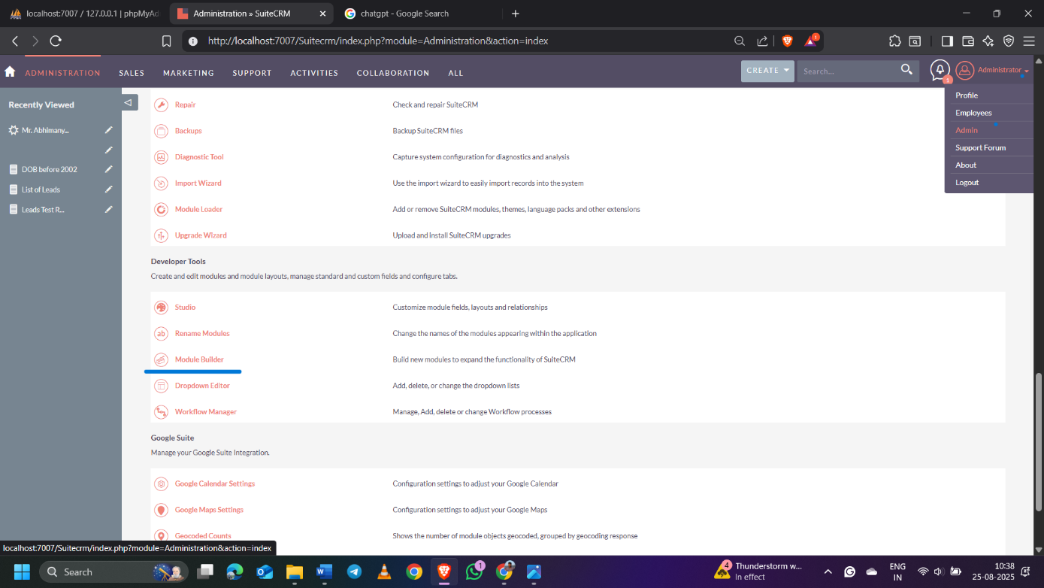

Step 2 : Add New Package.

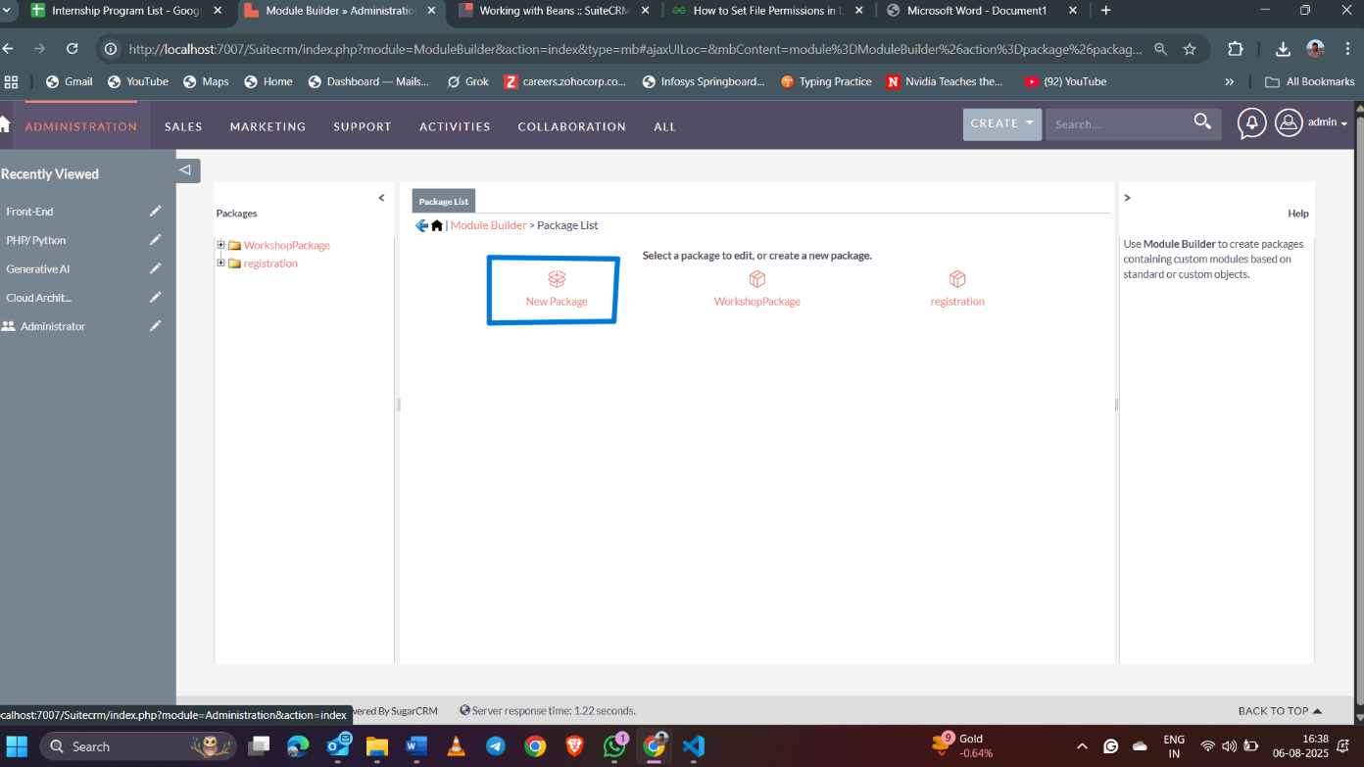

Step 3 : Write the Package name, Author as Unify, and Key is UNF, and save

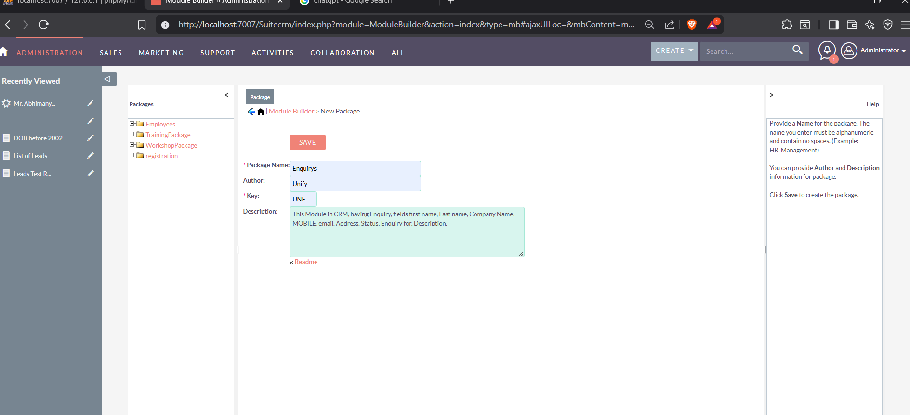

Step 4 : Create New Module.

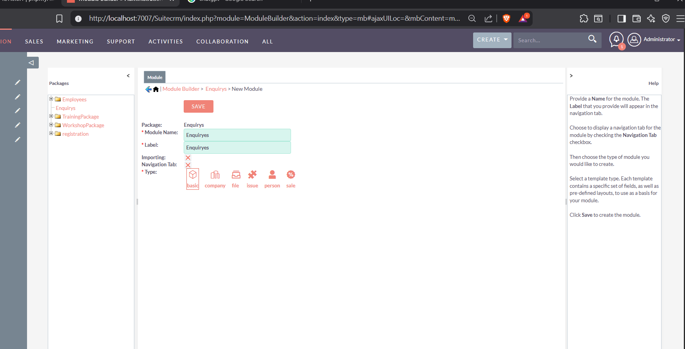

Step 5: Enter the module name, Label, and Tick mark importing so we can import the module and select the basic type.

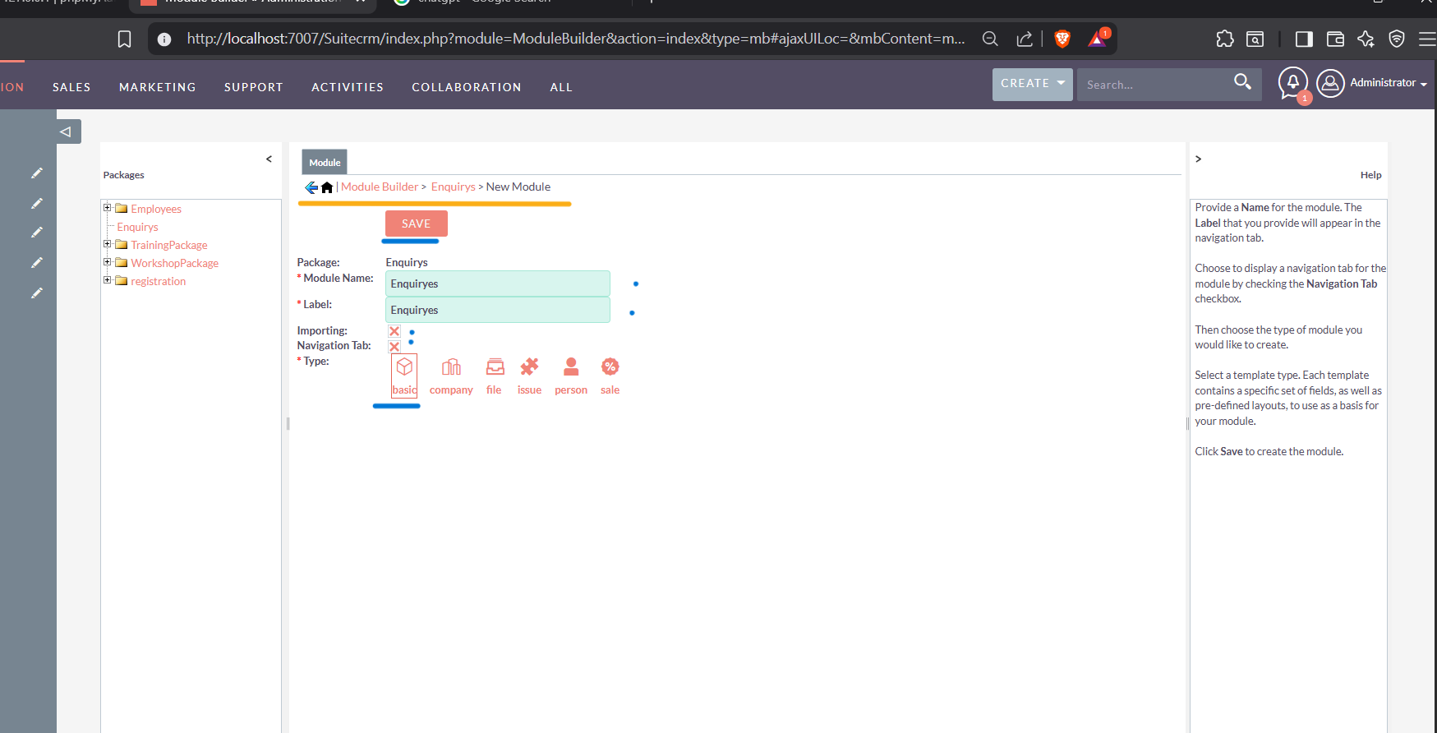

Step 6 : Select View Fields and add some fields with data types and a Display label

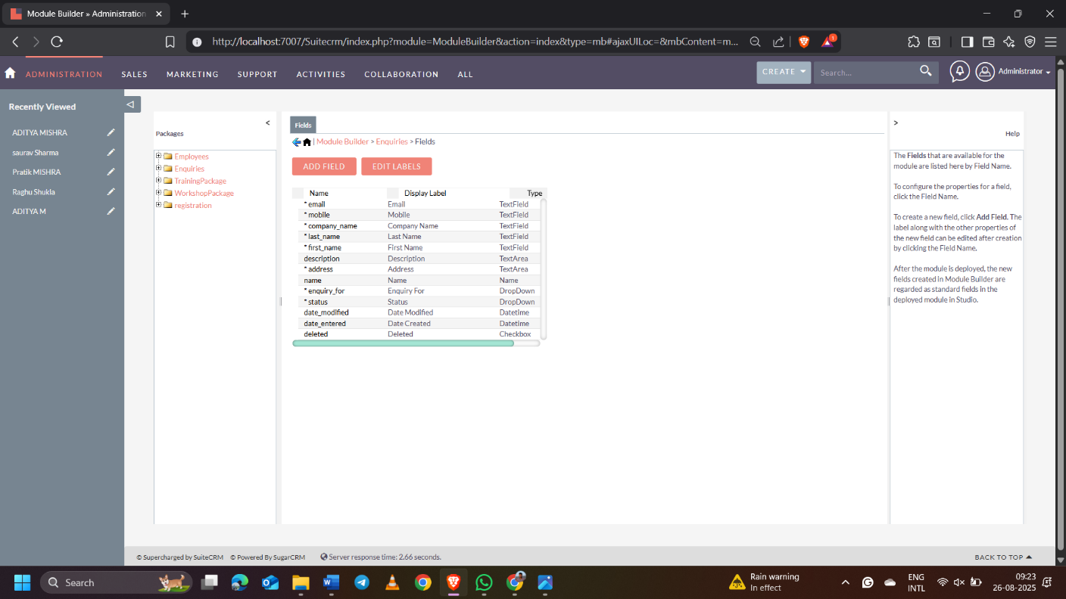

Step 7 : select data type, add field name, Display name, Tick the required field, and in audit, untick inline edit and save.

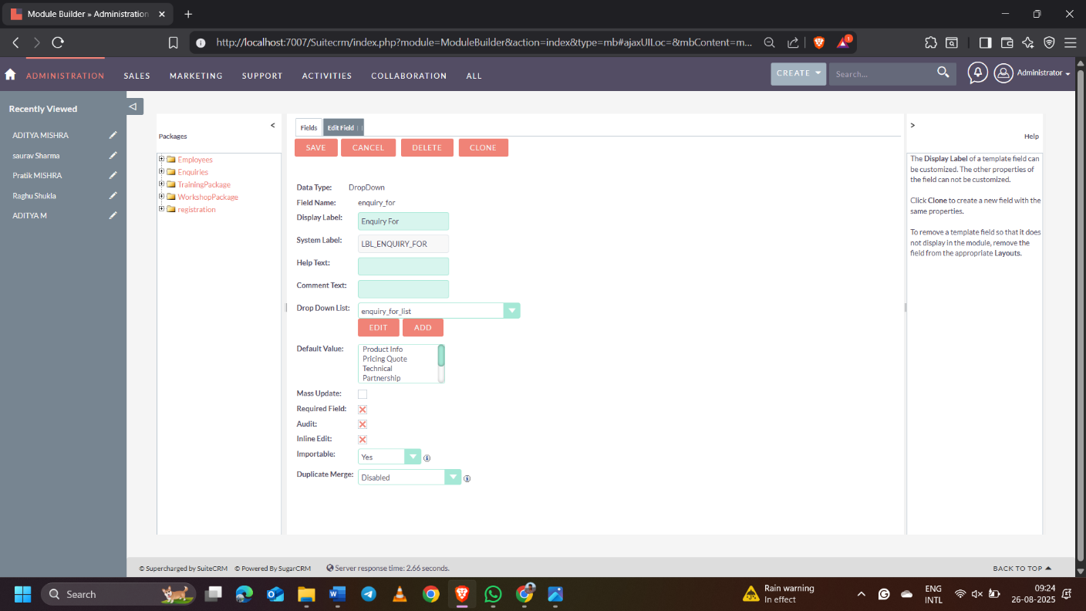

Step 8 : Open the View layout, and after that, open the Edit View

1.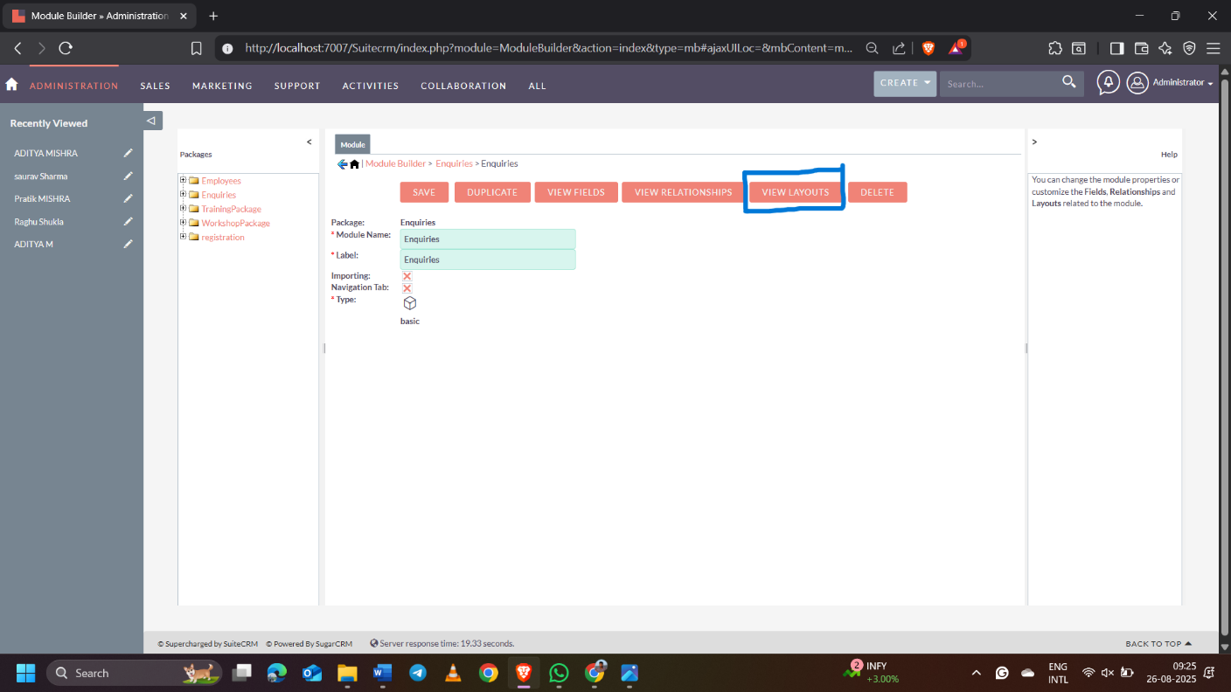

2.

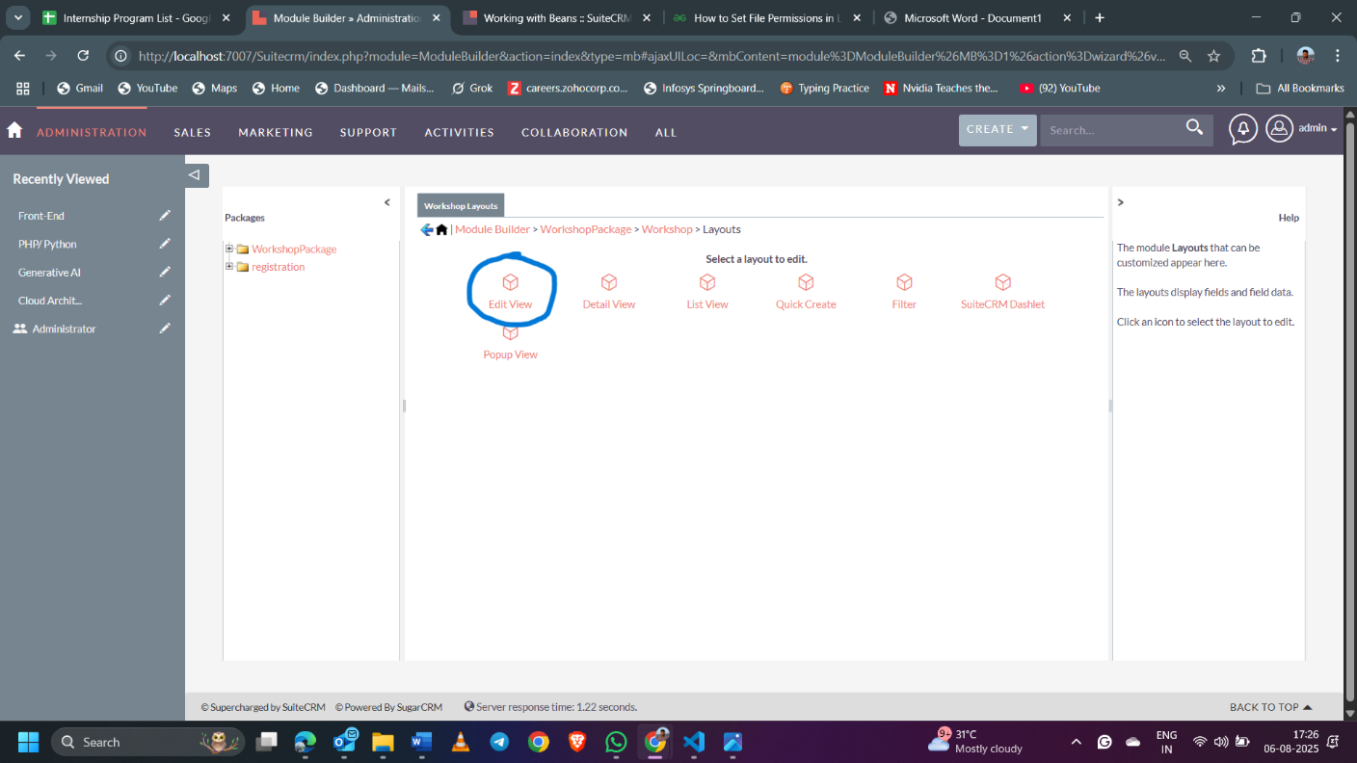

Step 9: Set Edit view as per your need, you can add new row and panel by dragging to layout and save.

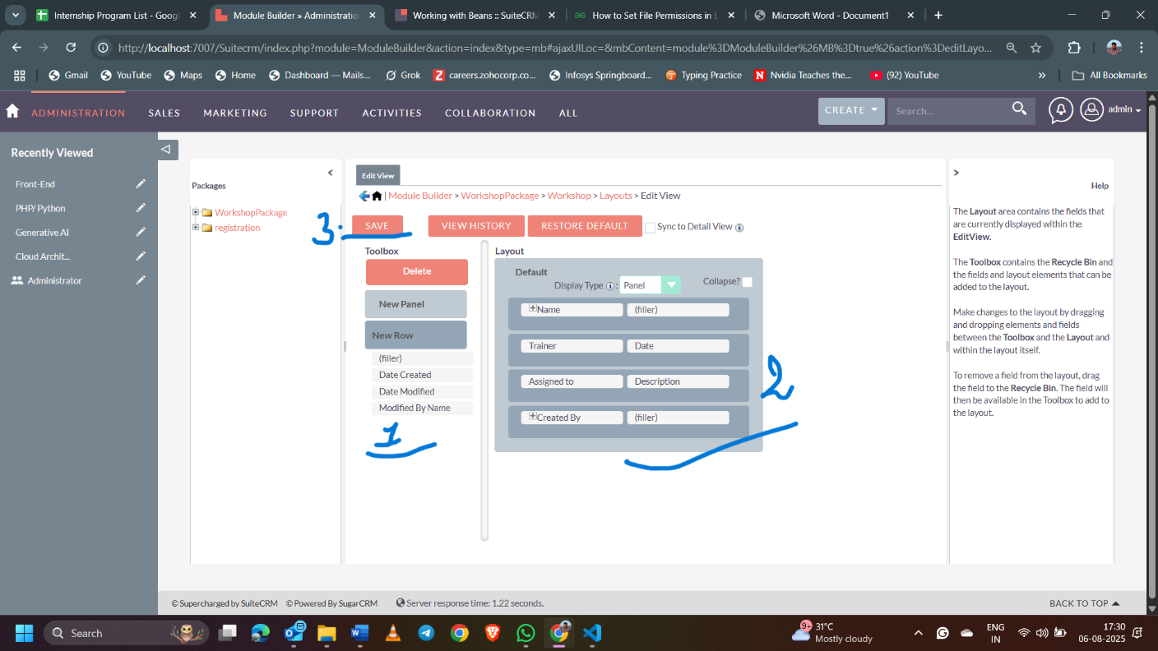

Step 10 : Copy from Edit View and add Date Created and Date Modified in Detail View.

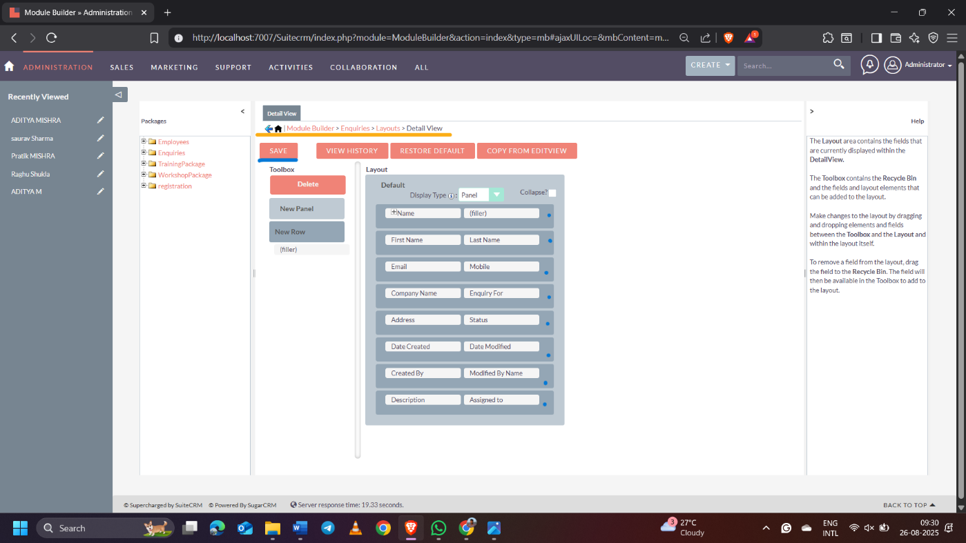

Step 11 : Come back to layouts and click List View, and Required fields dragged to left side less necessary fields to the middle, and unnecessary fields to the hidden.

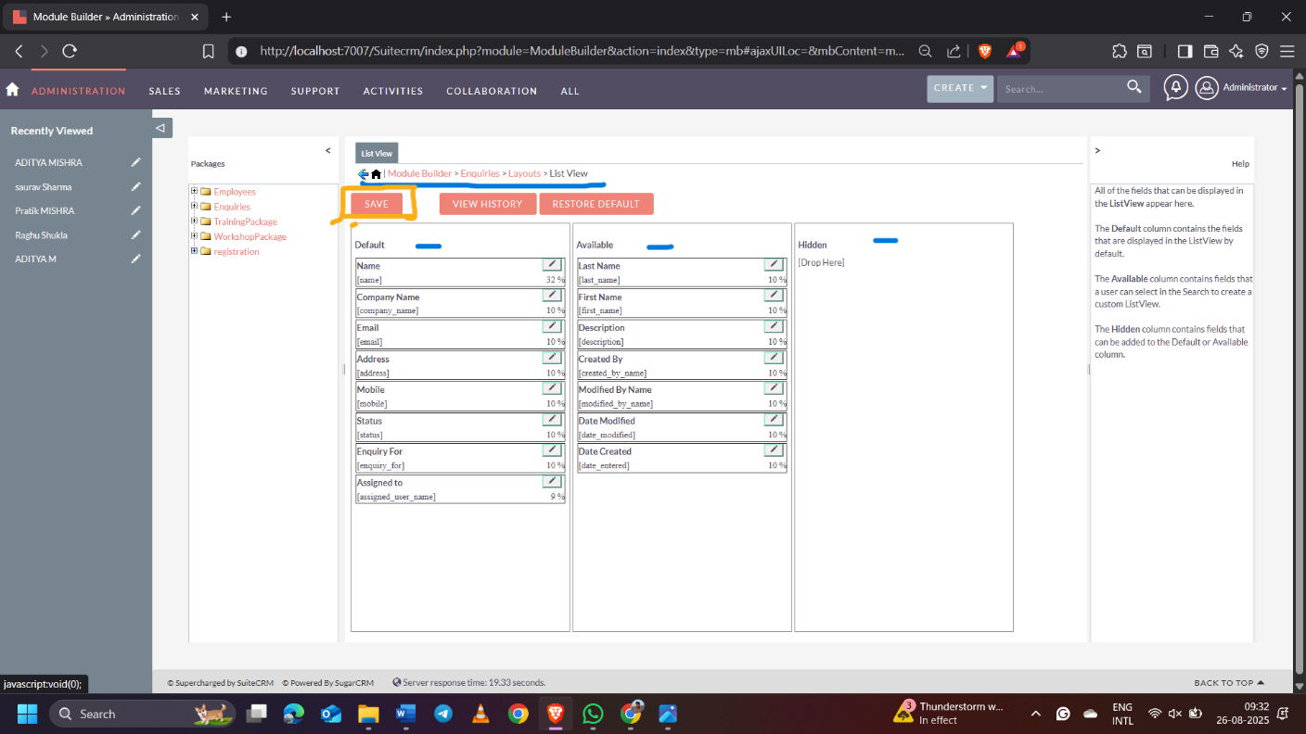

Step 12 : Back to layouts and click Quick Create and Copy from Edit view.

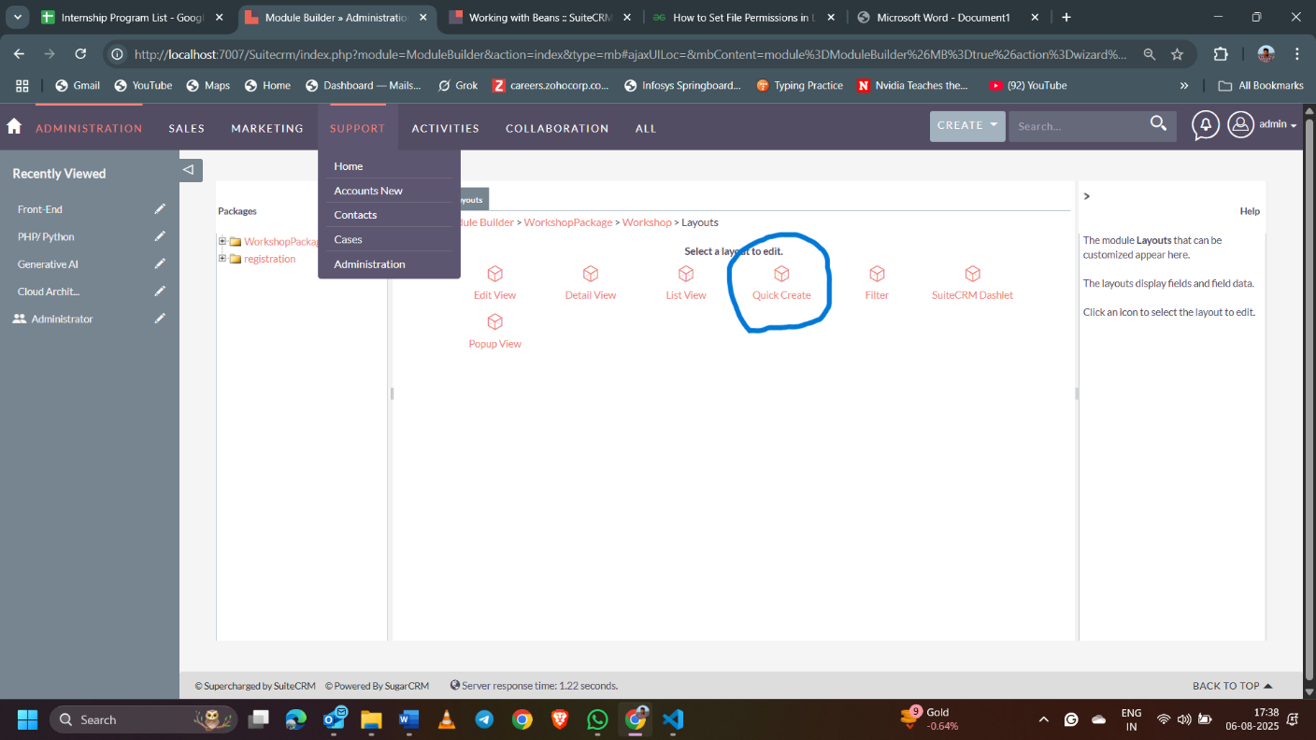

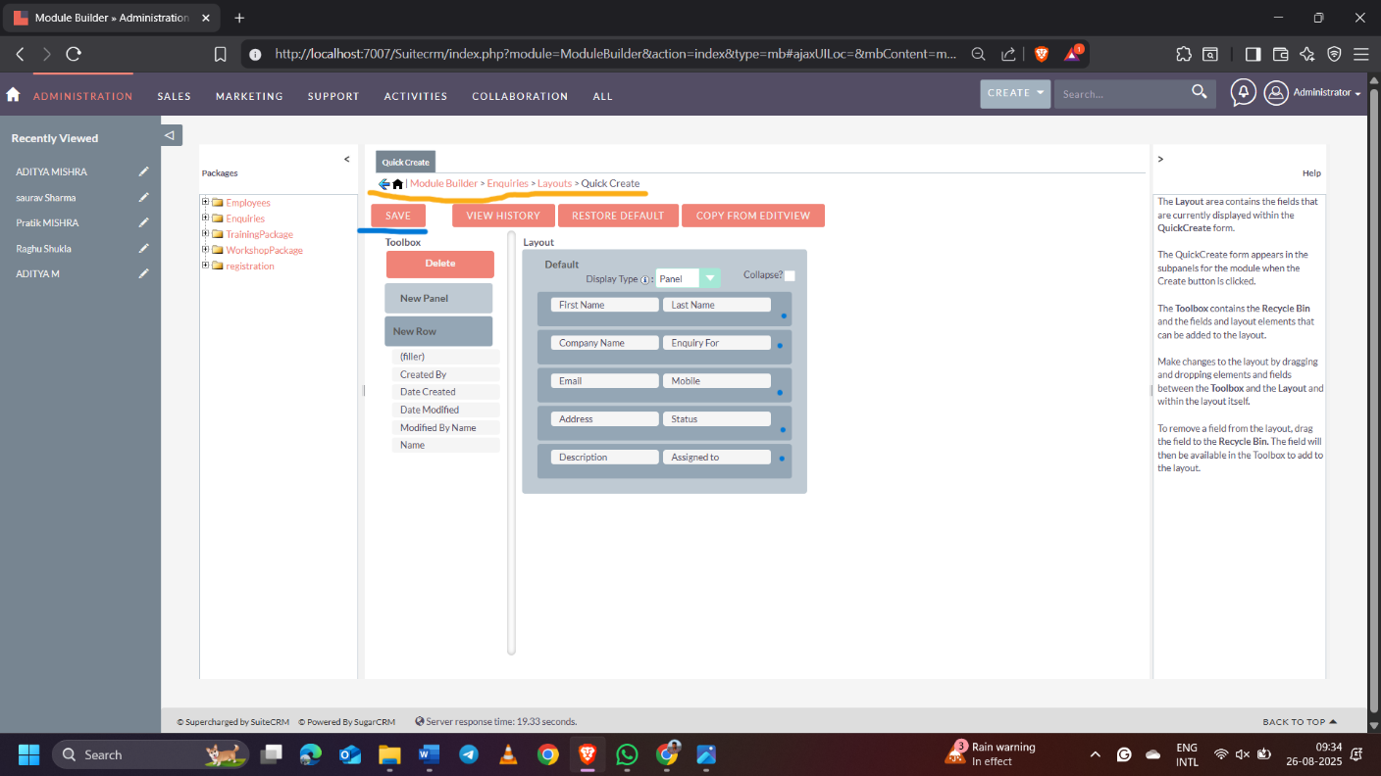

Step 13 : After Adding all Layouts, back to the Module and save then come back to the package and publish the Module.

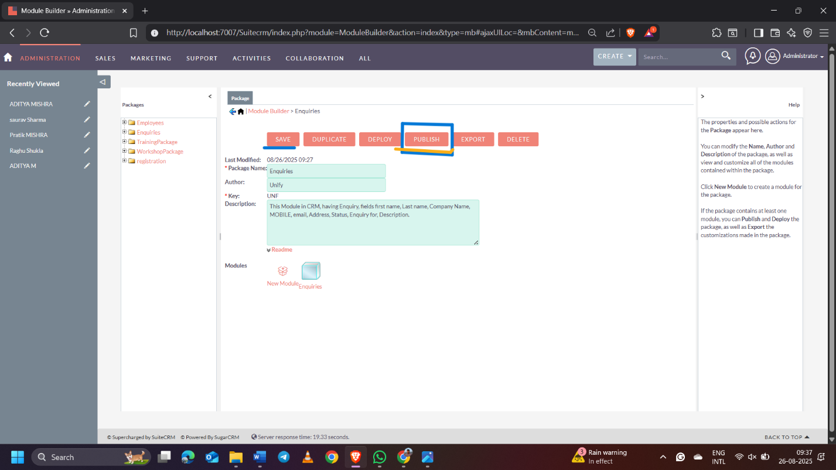

Step 14 : After downloading zip file(after just publish,automatically downloaded the zip folder) go to the module loader and install the module.

1.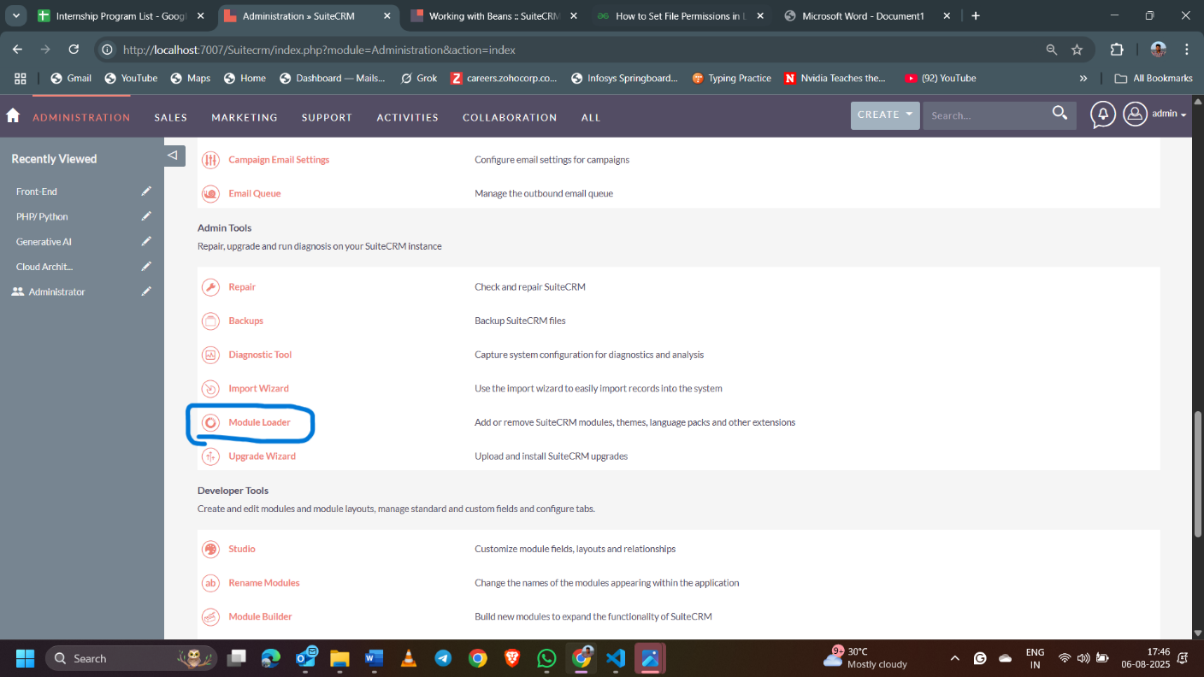

2. 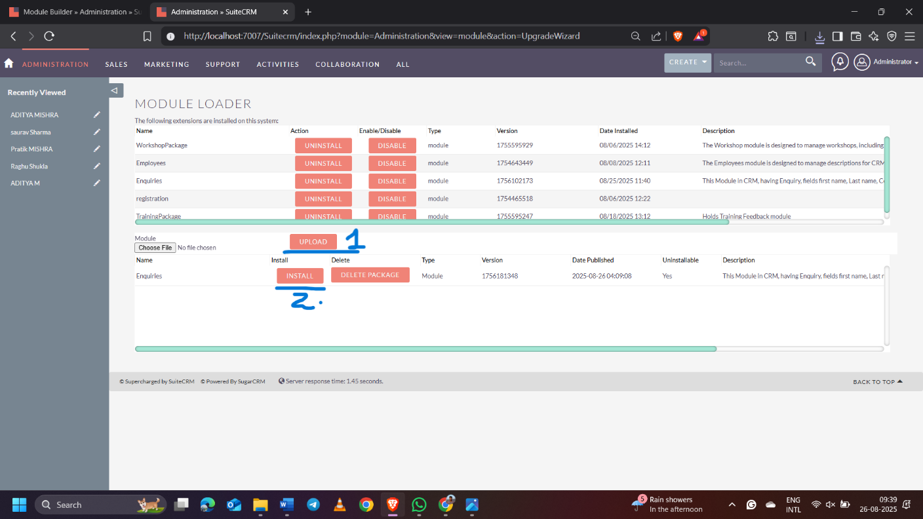

3. Install and then go to repair to synchronize the files.

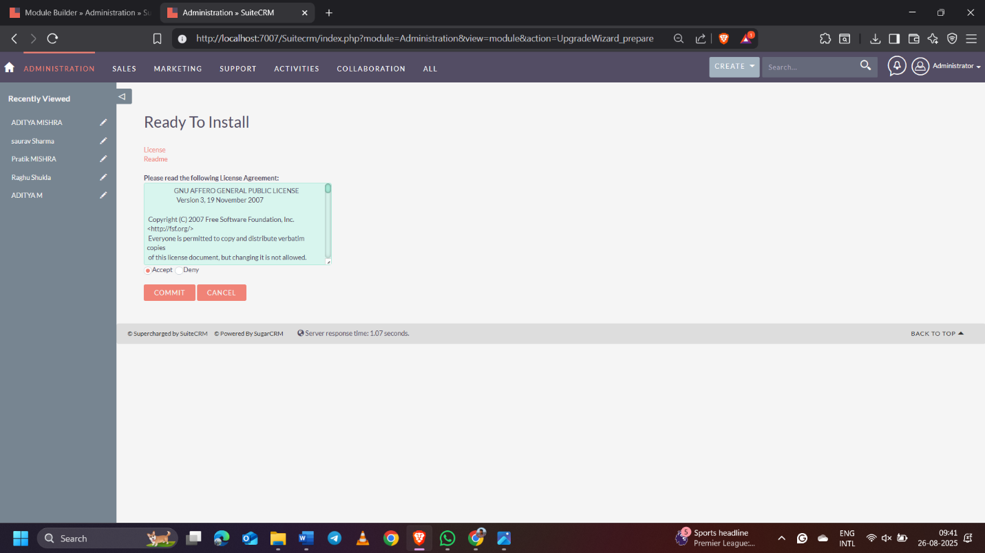

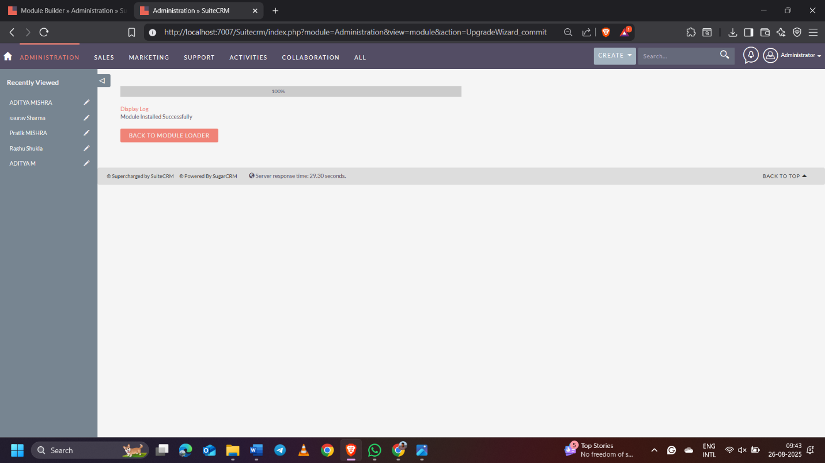

a.

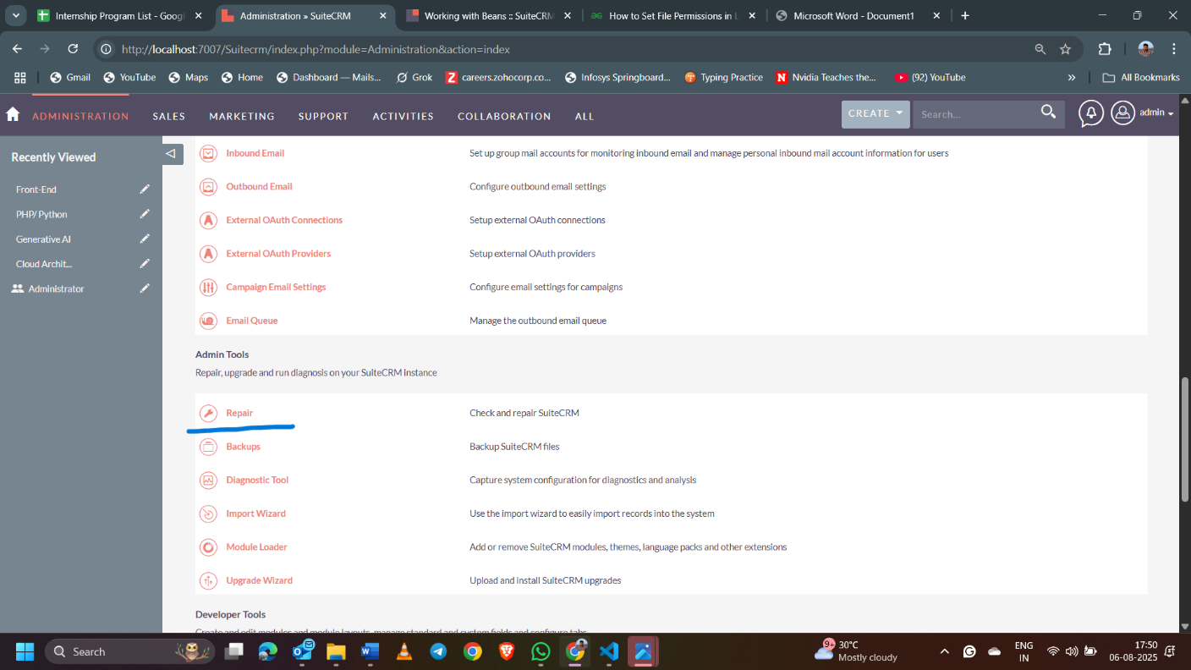

b.

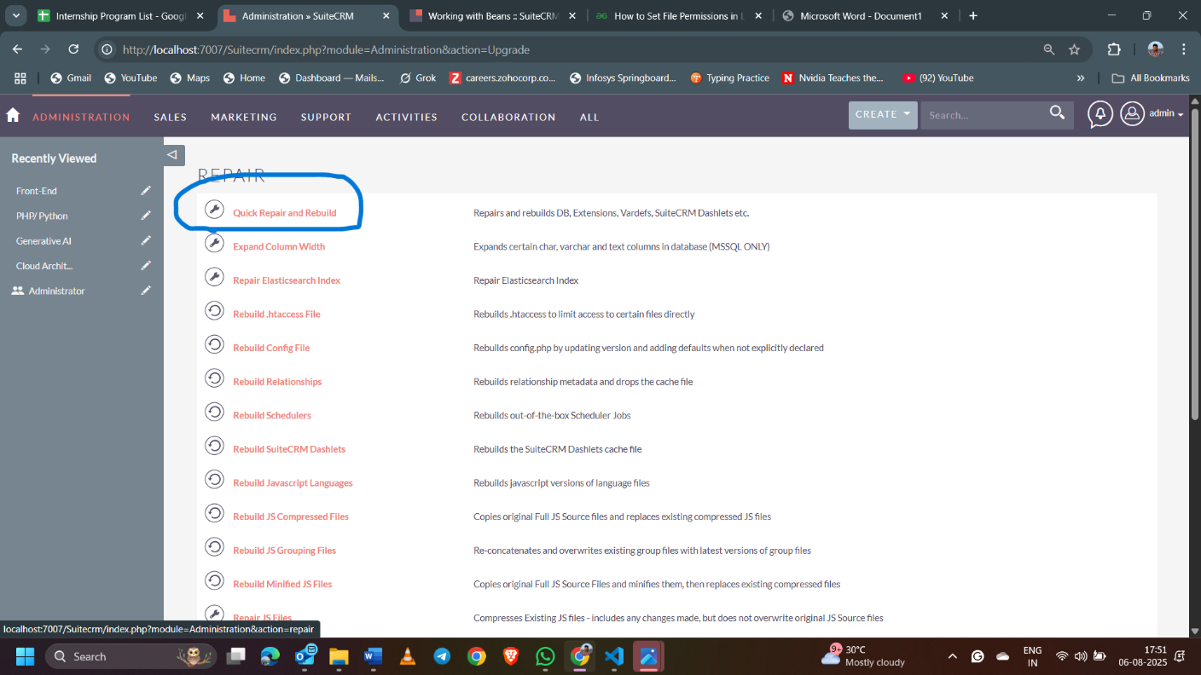

**Now, your module is ready and displayed here.**

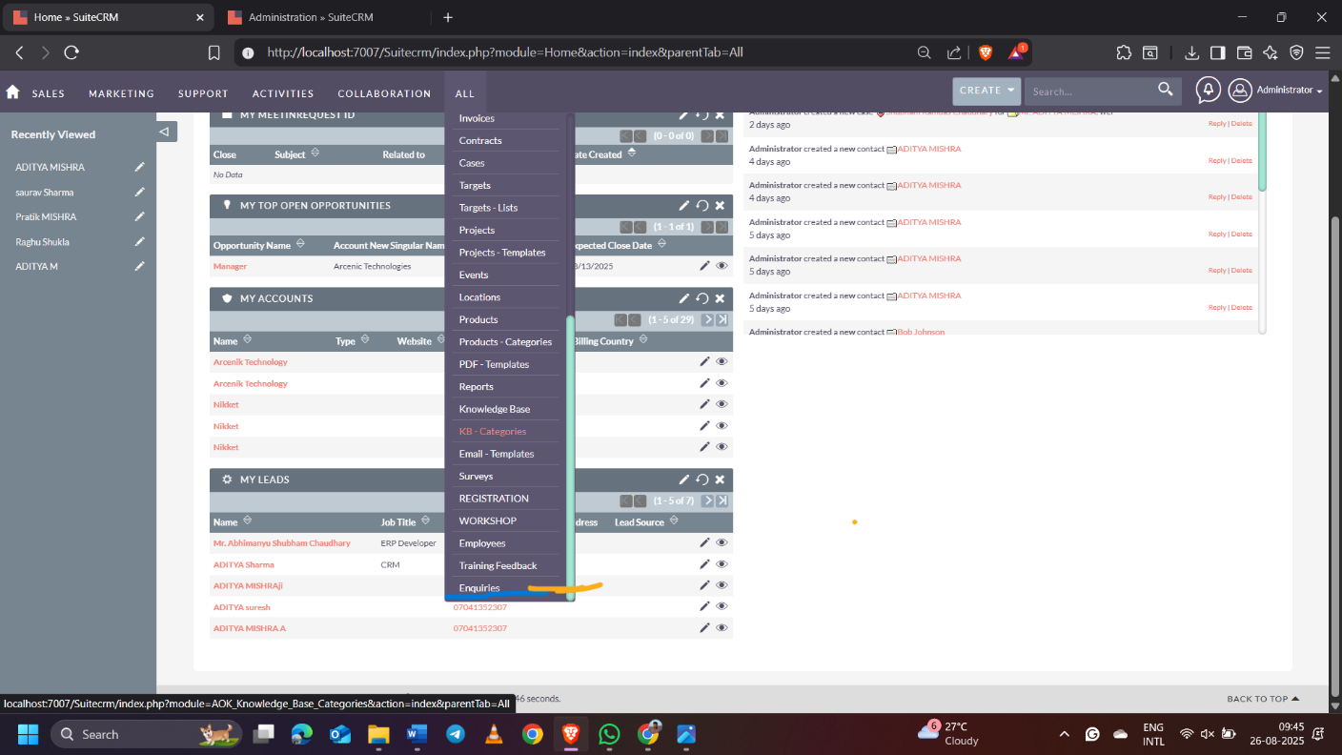

**Task 2: Create One Enquiry form outside crm. On form submit, create an enquiry in CRM.**